1.
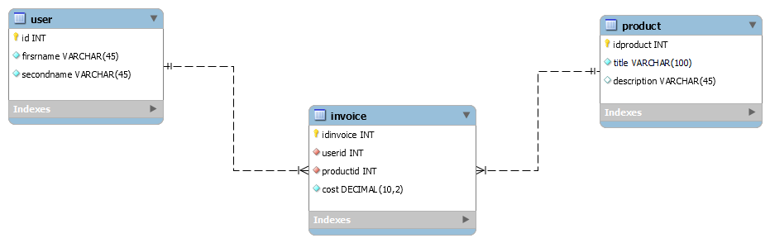
Запрос: https://gist.github.com/fuquyoma/e7bb92af2120c37e82588ff62c44871a
Фрагмент запроса для создания invoice:
CREATE TABLE IF NOT EXISTS `firstModel`.`invoice` (
`idinvoice` INT NOT NULL AUTO_INCREMENT,
`userid` INT NOT NULL,
`productid` INT NOT NULL,
`cost` DECIMAL(10,2) NOT NULL,
PRIMARY KEY (`idinvoice`),
INDEX `user_idx` (`userid` ASC) VISIBLE,
INDEX `prod_idx` (`productid` ASC) VISIBLE,
CONSTRAINT `user`
FOREIGN KEY (`userid`)
REFERENCES `firstModel`.`user` (`id`)
ON DELETE CASCADE
ON UPDATE CASCADE,
CONSTRAINT `prod`
FOREIGN KEY (`productid`)
REFERENCES `firstModel`.`product` (`idproduct`)
ON DELETE CASCADE
ON UPDATE CASCADE)
ENGINE = InnoDB;
2.
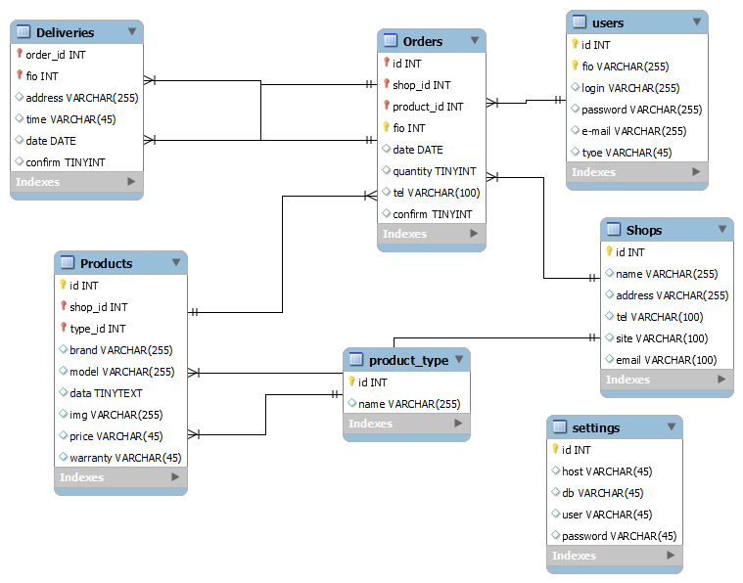

Запрос: https://gist.github.com/fuquyoma/8d43da7ccb2a8b9171d5bdec8ee3208e
Фрагмент запроса с Orders:
CREATE TABLE IF NOT EXISTS `mydb`.`Orders` (
`id` INT NOT NULL AUTO_INCREMENT,
`shop_id` INT NOT NULL,
`product_id` INT NOT NULL,
`fio` INT NOT NULL,
`date` DATE NULL,
`quantity` TINYINT NULL,
`tel` VARCHAR(100) NULL,
`confirm` TINYINT NULL,
PRIMARY KEY (`id`, `shop_id`, `product_id`, `fio`),
UNIQUE INDEX `id_UNIQUE` (`id` ASC) VISIBLE,
INDEX `shopid_to prod_idx` (`product_id` ASC) VISIBLE,
INDEX `shopid_to_shop_idx` (`shop_id` ASC) VISIBLE,
CONSTRAINT `shopid_to prod`
FOREIGN KEY (`product_id`)
REFERENCES `mydb`.`Products` (`id`)
ON DELETE CASCADE
ON UPDATE CASCADE,
CONSTRAINT `shopid_to_shop`
FOREIGN KEY (`shop_id`)
REFERENCES `mydb`.`Shops` (`id`)
ON DELETE CASCADE
ON UPDATE CASCADE,
CONSTRAINT `fio_to_user`
FOREIGN KEY (`id`)
REFERENCES `mydb`.`users` (`id`)
ON DELETE CASCADE
ON UPDATE CASCADE)
ENGINE = InnoDB;

3.
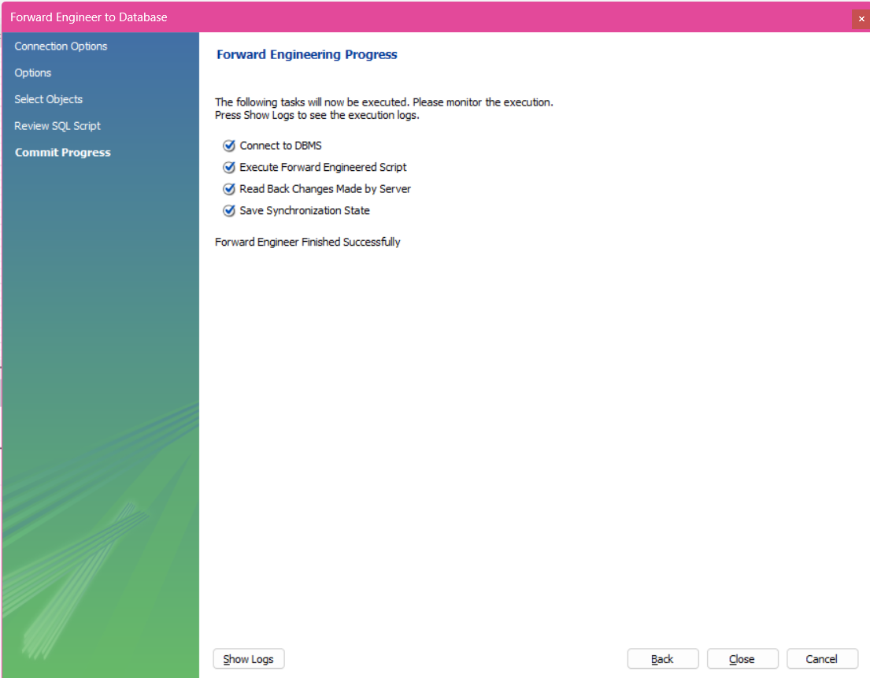

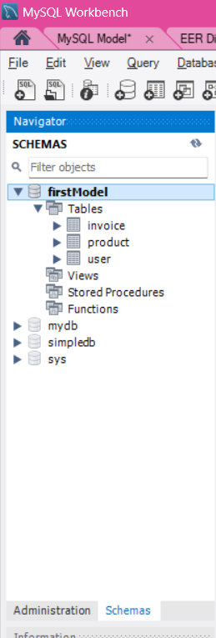

4. Если удалять при помощи каскадного удаления, то все связанные записи в таблице будут автоматически удалены.
Если удалять без каскадного удаления, то выведет ошибку

